Contributor: Patricia Andrea Dosio

**Fader, Fernando**

**(**Born: 1882 - Bordeaux, France; Died: 1935 - Ischilín Department, Córdoba, Argentina.)

The work of the French-born Argentine artist Fernando Fader is one of the most prominent and appreciated in Argentina. Fader was born in Bordeaux, France, but his family settled in Mendoza, Argentina just a few years later. His parents, a German engineer and a French viscountess, sent Fader to Europe to complete his primary and secondary school in France and Germany. After a brief training in Mendoza, where Fader depicted urban landscapes, he moved to Germany to study art at the Munich Academy of Fine Arts with Heinrich von Zügel, a specialist in pictures of animals in an impressionistic style. Von Zügel stimulated Fader to work in *plein air* (outdoors) painting. His spontaneous techniques, vibrant colours and brushstrokes contributed to the introduction of Modernism in the local artistic field. After the death of his father, Fader took over family business. In 1913 a flood destroyed the power station of his company in Mendoza, which eventually went bankrupt. Because of this, he decided to move to Buenos Aires and dedicate entirely to painting. He died in Loza Corral, Ischilín Department, Córdoba province, on February 25, 1935.

When Fernando Fader returned to Argentina, in 1904, he founded a painting school in Mendoza. His first exhibition in Buenos Aires established him as a recognised Impressionist painter, despite the fact that critics and the general public did not fully accept this style. Between 1907 and 1909 Fader integrated the Nexus group along with Pío Collivadino, Carlos Ripamonte, and **Cesáreo Bernaldo de Quirós**, among other artists. In 1914 the artist presented in the IV Salón Nacional de Bellas Artes, (IV National Exhibition of Fine Arts), of Buenos Aires, the painting *Los mantones de Manila, (The shawls of Manila)*, which obtained the First Acquisition Award. However, Fader rejected it and kept the painting until his death, when it was bought by his merchant, Federico Müller.

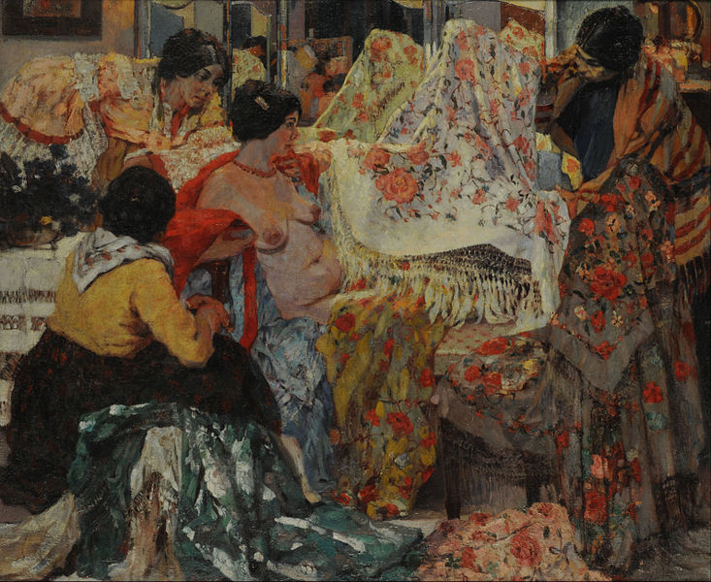

Fernando Fader, *Los mantones de Manila, (The shawls of Manila)*, 1914, oil on canvas, 45.67 x 55.12 inches, Museo Nacional de Bellas Artes, Buenos Aires.

<http://commons.wikimedia.org/wiki/File:Fernando_Fader_-_Los_mantones_de_Manila_-_Google_Art_Project.jpg>

He took part in the international exhibition in San Francisco in 1915, where he won a gold medal for *La comida de los cerdos, (The food of pigs)*. This painting had already been awarded in Munich in 1904. At the beginning of the following year, on medical advice, Fader went to live definitely in Córdoba (Argentina). Since then, the scenery of this province was the main pictorial motif of his work. But, in 1921 Fader gave up depicting outdoors and started doing work in his studio. Because of his illness, Fader could not attend his tribute exhibition in 1932.

His appropriation of the impressionist style was welcome in the still conservative Argentine artistic field. In *Los mantones de Manila*, Fader abandoned figurativism and academic rules, focusing the effects of vibrant tones and highlights, clear and contrast colours, which became a characteristic of his works between 1913 and 1915. Fader used to apply the paint with short and pasted strokes, sometimes with a spatula. His more significant features are the highlights in figures and scenes, rich colouring, thick impasto and his preference for natural sceneries, characteristics that influenced several young artists.

Famous for his paintings of landscapes and rural culture, Fader founded with other artists the Nexus group. This group aimed at creating an art independent of European norms by focusing on traditional and native topics as well as the changes in the urban landscape caused by the advent of modernization.

During 1917 Fader began producing one of his more remarkable works, the series of eight canvas *La vida de un día, (Life of a day),* exhibited that year in Müller gallery, Buenos Aires*.* In a similar way as Monet, Fader painted a same place, his ranch in Córdoba, at different hours of a day with the aim of observing the changes caused by the natural light on the landscape.

Due to his inability to paint outdoors, in 1921 he started the series of nude females, different from previous works of his because of its classical composition. Fader renewed Argentine national painting, marking the end of its academic period, and contributed to the formation of a national style.

**Bibliographic Sources:**

Lascano González, A. (1966) *Fernando Fader*. Buenos Aires: Ediciones Culturales Argentinas, p. 23-25.

Collazo, A. (1980) *Fader. Pintores argentinos del siglo XX*. Buenos Aires: Centro Editor de América Latina.

Gutiérrez Viñuales, R. (1998) *Fernando Fader: obra y pensamiento de un pintor argentino*. Granada: Instituto de América/CEDODAL.

Gutierrez Zaldívar, I. (2001) *Fader*. Buenos Aires: Zurbarán.

**Video about Fader:**

*Huellas. Arte argentino: Fernando Fader I*. Canal Encuentro.

<http://www.youtube.com/watch?v=ma9Cg3040XM>

**List of Works:**

Fernando Fader, *La comida de los cerdos*, *(The food of pigs),* 1904, oil on canvas, 51.18 x 39.37 inches, Museo Nacional de Bellas Artes, Buenos Aires.

Fernando Fader, *Los mantones de Manila, (The shawls of Manila)*, 1914, oil on canvas, 45.67 x 55.12 inches, Museo Nacional de Bellas Artes, Buenos Aires.

Fernando Fader, *Fin de invierno, (End of winter)*, 1918, 39.37 x 47.24 inches, Museo Nacional de Bellas Artes, Buenos Aires.

Fernando Fader, *Desnudo, (Nude),* 1921, oil on canvas, 43.30 x 59.05 inches, Museo Municipal de Bellas Artes Juan B. Castagnino, Rosario.

Fernando Fader, *Pocho (Córdoba),* 1930, oil on canvas, 31.5 x 39.37 inches, Museo Nacional de Bellas Artes, Buenos Aires.

Fernando Fader, *La vida de un día,* (*Life of a day*), series of eight canvas, 1917, oil on canvas, 31.49 x 39.37 inches, Museo Municipal de Bellas Artes Juan B. Castagnino, Rosario.